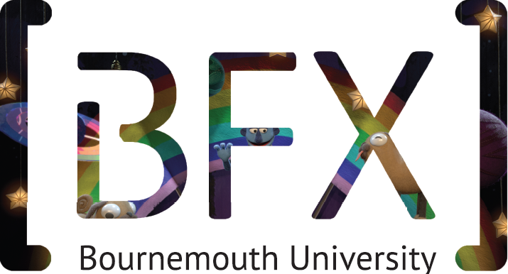

How to apply

Competition Guidebook

Contents

1. Key dates 2018

2. The basics

3. How to apply

a. Form a team

b. Organize your team

c. Compile your supporting information (Individuals)

d. Read the Terms & Conditions

e. Submit your application online

4. F.A.Q

5. What happens next?

1. Key dates 2018

Applications open 2nd January 2018

Applications close 28th February 2018

Team selection 1st March 2018

Script Draw 5th March 2018

Storyboard, animatic, 28th May 2018
environment and
character design
1st draft deadline

Competition Monday 9th July – Friday 24th August 2018

Awards/prize giving Thursday 4th October 2018 (subject to change)

2. The basics

The BFX Competition is FREE to enter and all teams will be hosted at Bournemouth University (BU).
Participates will be provided with accommodation and given a stipend for living expenses. Participants must be 18 years or over at the time of application and be available for the full
competition period.

Teams will live on campus at BU free of charge for seven weeks, during this period they will have access to the facilities of the NCCA including studios, workstations/software platforms, cameras and lights. In 2017 teams were mentored and judged by experts from Double Negative, MPC, Aardman, Hibbert Ralph Animation, Blue Bolt, Outpost VFX, Blind Pig and Blue Zoo, something we are looking to in 2018, both in person and over the Internet. Teams will also have the support of academic staff and technicians.

3. How to apply

a. Form a team

You need to be a team of 5 containing a balance of artists, technical directors and/or programmers. In addition to this your team must have someone willing to take on the role of team leader in addition to their creative/ technical duties. To be eligible to apply to enter the Competition, you must be over 18 years old.

You must be a team of students (postgraduates and/or undergraduates) at a Higher
Education Institution (University or Art College) studying in the UK. Team members do not need to be studying or have studied at the same University/College. Students studying at
Universities from overseas may be invited to compete this year as well.
BFX Teams shall be made up as follows:
• In a team of 5 at least 3 members must be currently undertaking graduate or postgraduate studies at a UK University or Arts Institute.
• The remaining team members may either have graduated from a UK University, Arts Institute or College of Further Education within the last two years or be studying at a College of Further Education or be any combination.
Please note, if you are a graduate you need to have had no more than 8 months’ full time relevant work experience within the last three years and not be currently employed in the VFX, Animation or games/interactive entertainment industries. Internships or placements undertaken during study will not be construed as “relevant work experience”.
• In a team of 5 students you can only have 2 previous BFX Competitors.

If you are looking for another member of the team, then use our Facebook group page to meet potential partners https://www.facebook.com/groups/bfxcompetition/

b. Organize your team

• Choose a team name
• Assign everyone a role
• Decide who will be your Team Leader

Team leaders will be responsible for gathering all the information from individual team members, submitting the application and will be the main point of contact during the application process.

c. Compile your Supporting Information: Individuals

In addition to your team application each group member will also need to submit the following information:

• Showreel
A URL (to Vimeo or YouTube) of your personal portfolio/ showreel illustrating the skills which you’ll be demonstrating during the competition.

• Team statement
Please submit a short paragraph outlining what the team will gain from being in the competition.

d. Read the Terms & Conditions

These can be found online at http://www.bfxfestival.com/competition/competition-terms-conditions/

e. Submit your Application

When you have all your supporting material available, download the electronic application at www.bfxfestival.com/competition. Complete all fields and submit no later than 12 noon (GMT) 28th February 2017 by going to http://www.bfxfestival.com/competition/apply-now/

4) F.A.Q

If you have any questions about the application process or taking part in BFX, please check the Frequently Asked Questions section on the BFX website. If you don’t find your answer you can contact a member of the team at competition@bfxfestival.com

5) What happens next?

• Submission confirmation
On submission of the application, the team leader will receive an email confirming receipt of the application. Should this not arrive within 3 hours, please check your Spam filter. Failing that, please contact competition@bfxfestival.com

• Successfully Selected teams
Successfully selected teams will be contacted by telephone on Friday 2nd March 2018. Unsuccessful teams will also be notified via email on the same date.

• Script draw
Each team will be randomly selected for 1 of the 8 scripts which will then become the teams brief for the competition on Monday 5th March 2018

Copyright of the screenplays is owned by the named Bournemouth University Scriptwriting student and is to be used for BFX Competition 2017 purposes only.

• Storyboards
Each team will be put in contact with Jerry Hibbert from Hibbert Ralph Animation on 6th March 2018. Each team is to work with Jerry on creating a storyboard and animatic for your chosen script. TBC

The BFX team will be available for any applicants looking for guidance or help regarding the storyboard and animatic. Please contact competition@bfxfestival.com to book an appointment.

• First draft deadline
First draft storyboards, animatics, environment and character designs to be sent to Tracey Ricketts (VFX Hub Project Coordinator): tricketts@bournemouth.ac.uk by 12noon on Monday 28th May 2018.

• Feedback
Feedback from the charities will be emailed to each team on Friday 1st June 2018. Changes must be made and ready for presenting during the competition on Wednesday 11th July.

• Competition starts
All teams to be at Bournemouth University ready to start the competition at 9am on Monday 9th July 2018.

GOOD LUCK

